MODULE: 1 (SDLC)
- What is software? What is software engineering?
Ans:- Software is a set of programs and instructions that tell a computer do.
It helps the computer perform specific tasks.
Example:-
Operating systems, web browsers, and mobile apps.

- Explain types of software?
Ans:- Software Engineering is the process of designing, developing, testing, and maintaining software using engineering principles.
- It helps create high-quality, reliable, and efficient software

- What is SDLC? Explain each phase of SDLC.
Ans:- SDLC (Software Development Life Cycle) is a process used to develop software step-by-step.
Phases of SDLC
  - Requirement Analysis
Understand what the user needs.
  - System Design
Plan the software structure and architecture.
  - Development (Coding)
Programmers write code.
  - Testing
Check software for bugs and errors.
  - Deployment
Software is released to users.
  - Maintenance
Fix bugs and update software after release.

- What is DFD? Create a DFD diagram on Flipkart.
Ans:- DFD (Data Flow Diagram) shows how data moves in a system.
It shows:
- Input
- Process
- Output
- Data storage
Example: DFD for Flipkart
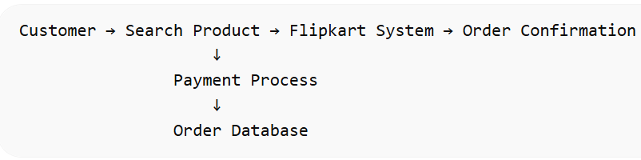
Steps:
- Customer searches product
- System displays product
- Customer places order
- Payment is processed
- Order stored in database
- What is Flow chart? Create a flowchart to make addition of two numbers.
Ans:- A Flowchart is a diagram that shows the step-by-step process of a program or system using symbols and arrows.
It helps to understand the logic of a program easily.
Common Flowchart Symbols
- Oval → Start / End
- Parallelogram → Input / Output
- Rectangle → Process
- Arrow → Flow of steps
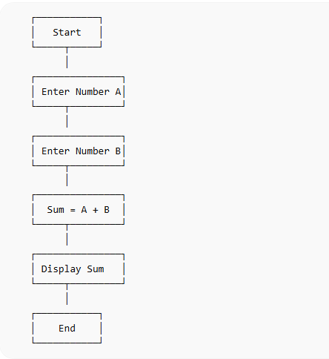
Steps
- Start the program
- Enter first number A
- Enter second number B
- Calculate Sum = A + B
- Display the result
- End the program

- What is Use case Diagram? Create a use-case on bill payment on paytm.
Ans:- A Use Case Diagram shows the interaction between users (actors) and a system.
Example: Bill Payment on Paytm
System: Paytm
Actors:
- User
- Paytm System
- Bank
